
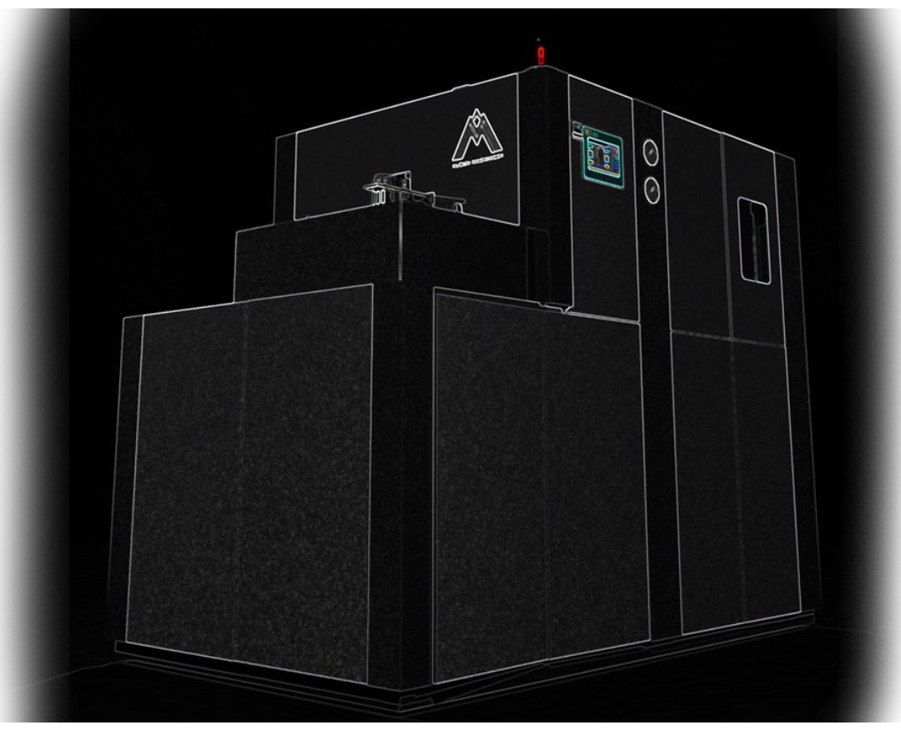

01

A L S U N M A C H I N E R Y

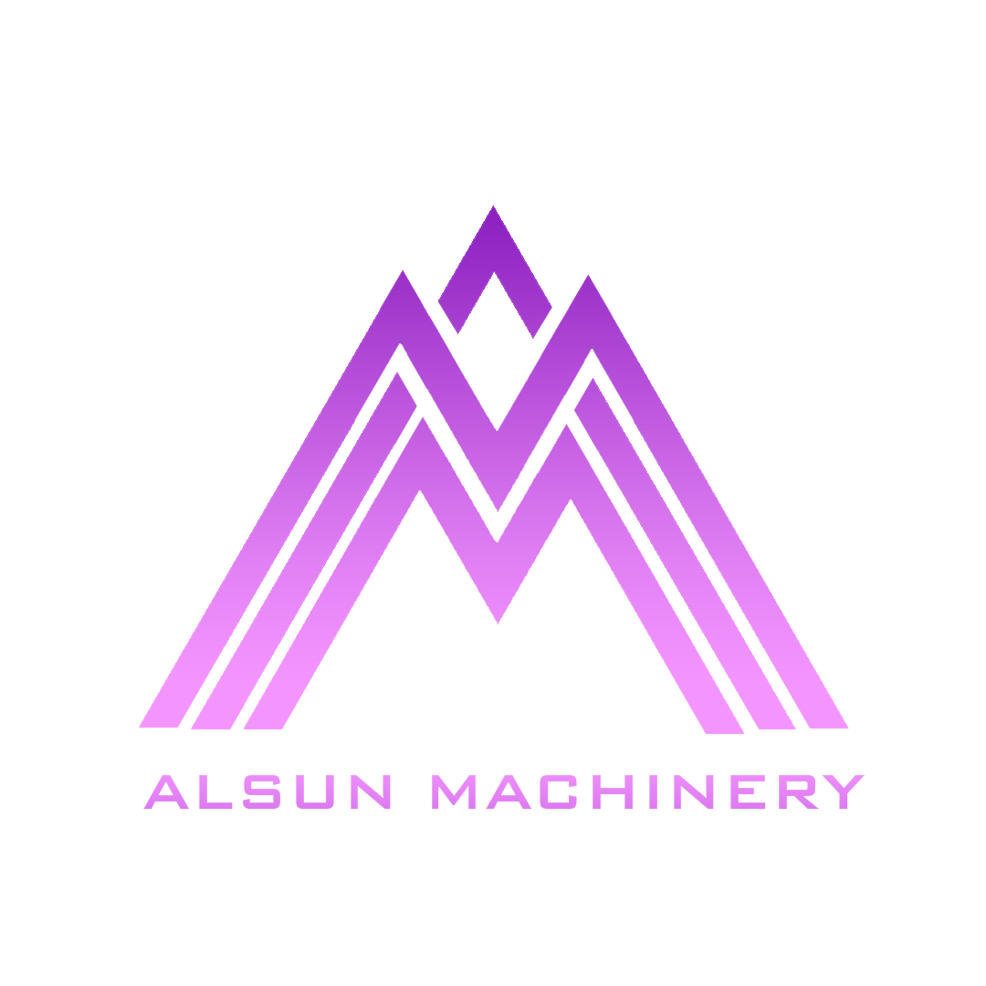
ALSUN
MACHINERY

Excellence in Every Blow
- We specialize in crafting cutting-edge PET and HDPE Blow Molding Machines, offering a complete range of Automatic and Semi-Automatic solutions for manufacturing jars, bottles, jerry cans, and more.

- Backed by years of expertise and a passion for precision engineering, our machines are built to deliver unmatched performance, durability, and efficiency.

- Whether you're a startup or an industry leader, Alsun Machinery is your trusted partner in turning ideas into perfectly shaped containers. Quality, innovation, and customer satisfaction are the pillars that define us — because at Alsun, we don’t just build machines, we build trust.


+ 9 1 7 8 2 7 4 3 4 3 9 2 | + 9 1 8 3 6 8 1 2 5 9 7 8
W W W . A L S U N M A C H I N E R Y . C O M

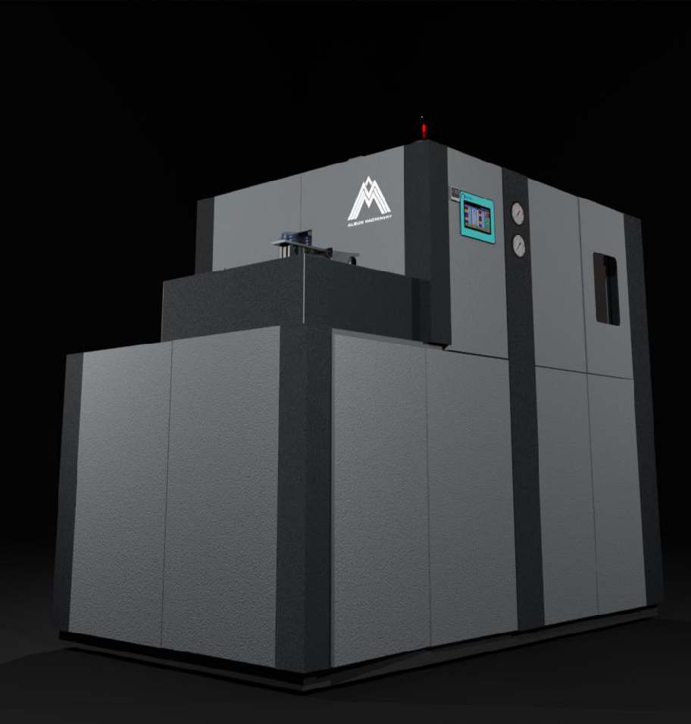

FULLY AUTOMATIC
03

PET BLOWING MACHINE

Automatic Machines – Built to Outperform
- Designed for efficiency and engineered for excellence, our Automatic Blow Molding Machines deliver high-speed, high- precision production of PET bottles.

- With fully automated operation, rugged construction, and minimal maintenance needs, these machines offer uninterrupted performance, superior output quality, and maximum productivity. Trusted by manufacturers who settle for nothing less than the best
— Alsun machines don’t just work hard, they work smart.


+ 9 1 7 8 2 7 4 3 4 3 9 2 | + 9 1 8 3 6 8 1 2 5 9 7 8
W W W . A L S U N M A C H I N E R Y . C O M



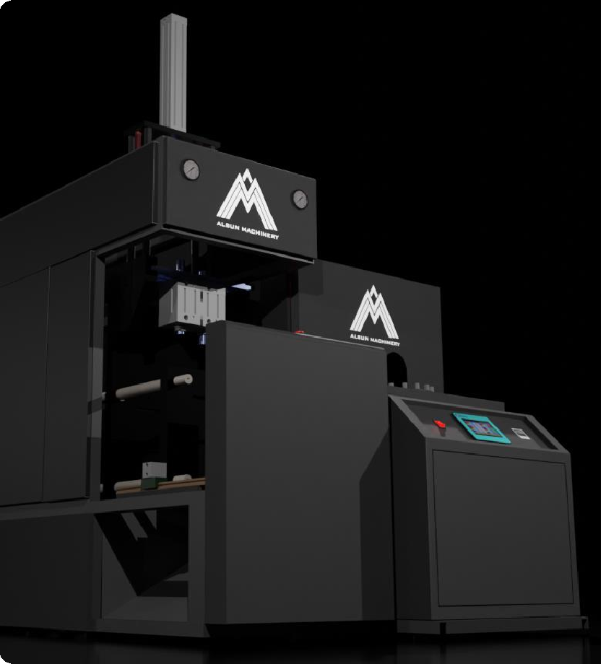

+ 9 1 7 8 2 7 4 3 4 3 9 2 | + 9 1 8 3 6 8 1 2 5 9 7 8

SEMI AUTOMATIC


PET BLOWING MACHINE
04

Smart Control. Powerful Performance.
Our Semi-Automatic Blow Molding Machines strike the perfect balance between precision engineering and operator-friendly design. Built to produce PET with consistency and class, they offer flexibility, durability, and exceptional value for growing businesses. Reliable, robust, and ready to deliver — every single cycle.

W W W . A L S U N M A C H I N E R Y . C O M


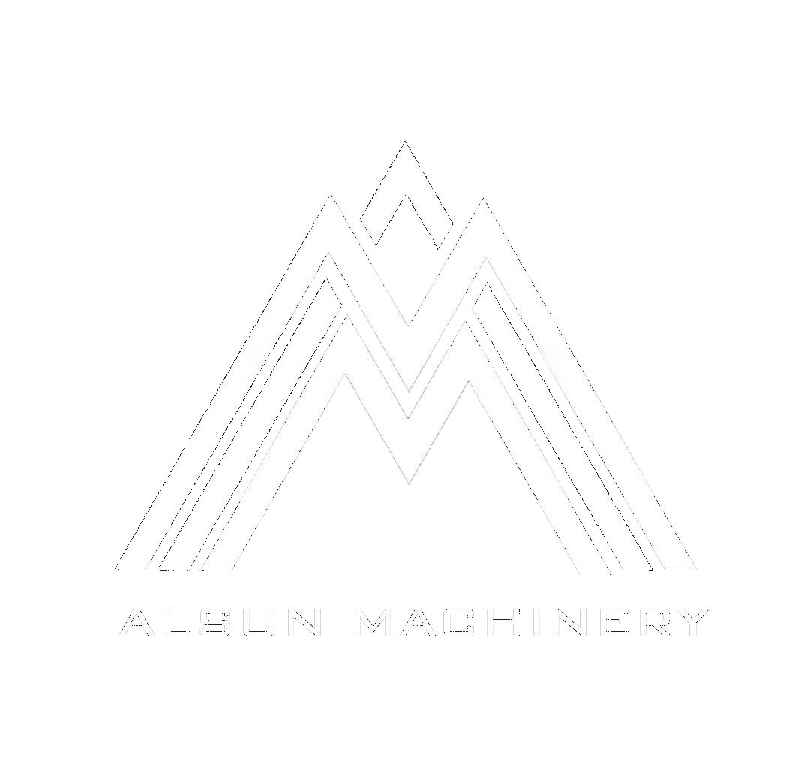
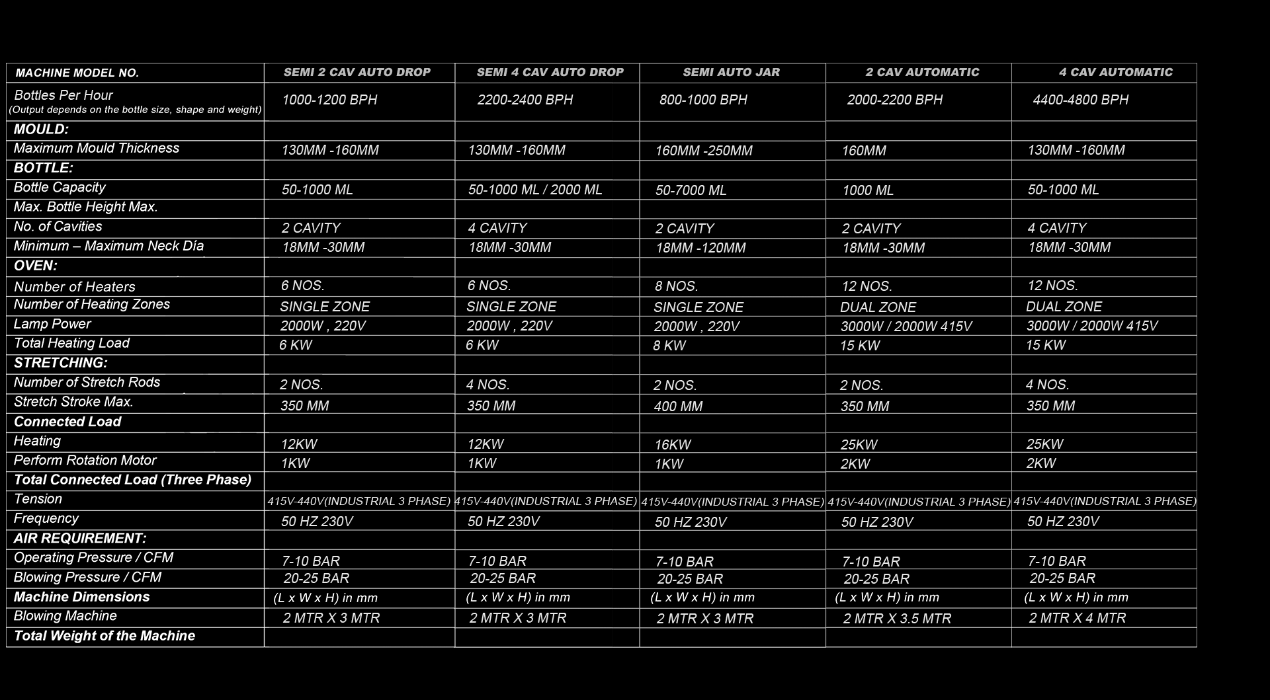
OUR RANGE
05

+ 9 1 7 8 2 7 4 3 4 3 9 2 | + 9 1 8 3 6 8 1 2 5 9 7 8 W W W . A L S U N M A C H I N E R Y . C O M



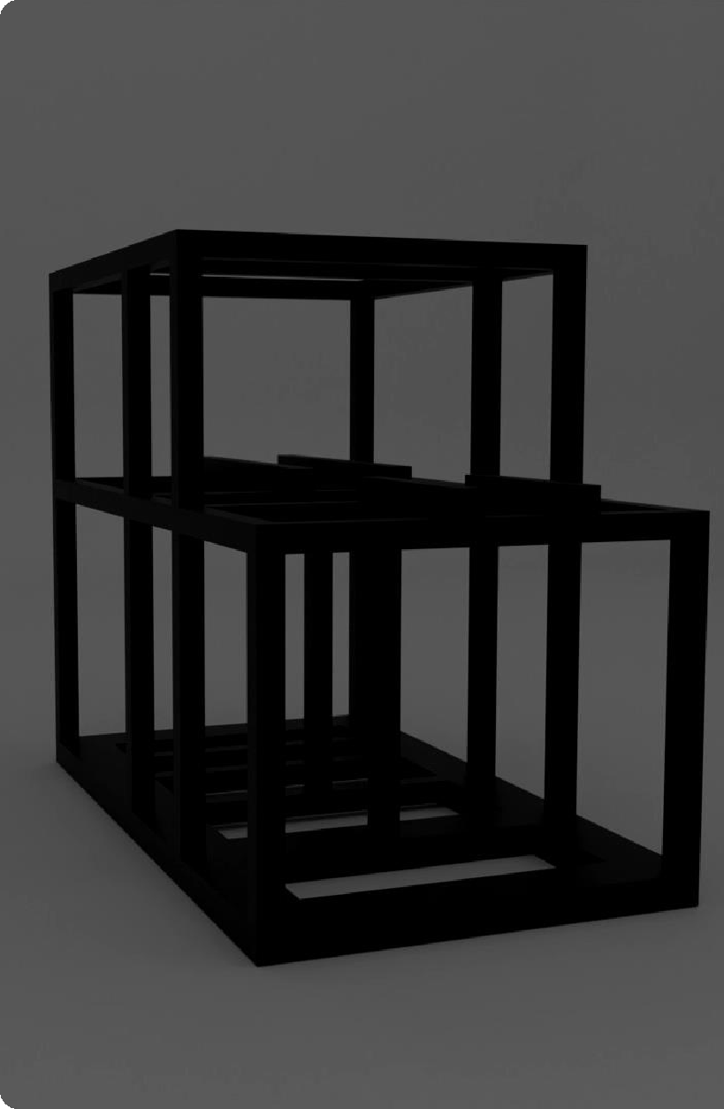
+ 9 1 7 8 2 7 4 3 4 3 9 2 | + 9 1 8 3 6 8 1 2 5 9 7 8

HEAVY PIPES

FOR STURDY BASE & BODY
06

  - Strength is the backbone of any great machine—and we go far beyond industry standards. Our blowers are constructed on an exceptionally strong structure using heavy square pipes, giving the base and body unmatched rigidity.

  - This robust foundation minimizes vibration, enhances machine stability, and ensures perfect operational alignment even in high- speed production environments. When you invest in our machine, you’re getting a powerhouse built to withstand rigorous, continuous industrial use without compromise.

W W W . A L S U N M A C H I N E R Y . C O M




ALL COMPONENTS
CNC & VMC MACHINED
- Every component of our blowing machine is meticulously manufactured on advanced CNC and VMC machinery. This gives each part an exceptional level of accuracy that simply cannot be matched by conventional fabrication methods.

- The result is a machine built with surgical precision—components fit perfectly, movements are smoother, and long-term performance remains consistently reliable. This is the kind of engineering excellence that ensures your production line runs flawlessly day after day, year after year.

+ 9 1 7 8 2 7 4 3 4 3 9 2 | + 9 1 8 3 6 8 1 2 5 9 7 8

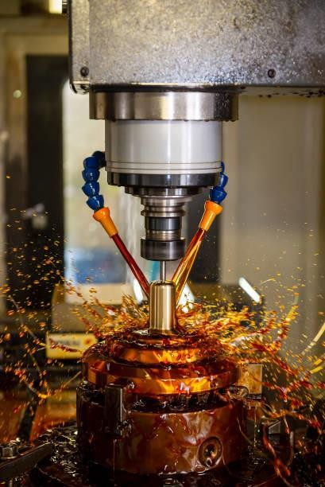
W W W . A L S U N M A C H I N E R Y . C O M
07



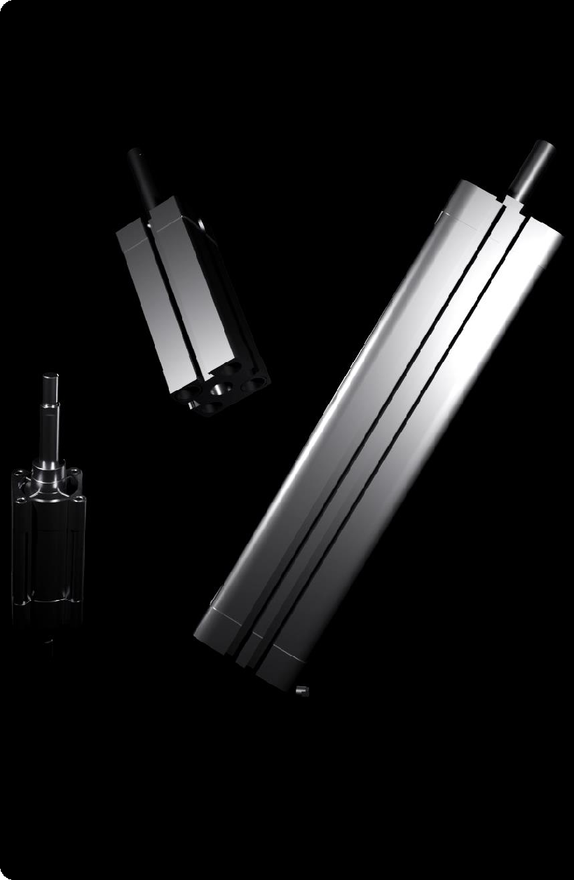
+ 9 1 7 8 2 7 4 3 4 3 9 2 | + 9 1 8 3 6 8 1 2 5 9 7 8

FESTO

PNEUMATIC CYLINDERS
08

  - Pneumatics play a crucial role in the speed and accuracy of bottle blowing, and that’s why we trust Festo—the world standard in pneumatic technology. Their cylinders are engineered for precision, long life, and ultra-responsive movement.

  - By equipping our machines with Festo components, we provide smooth, fast, and highly reliable motion control that translates directly into higher output and superior bottle quality.

W W W . A L S U N M A C H I N E R Y . C O M


LATEST TECHNOLOGY-

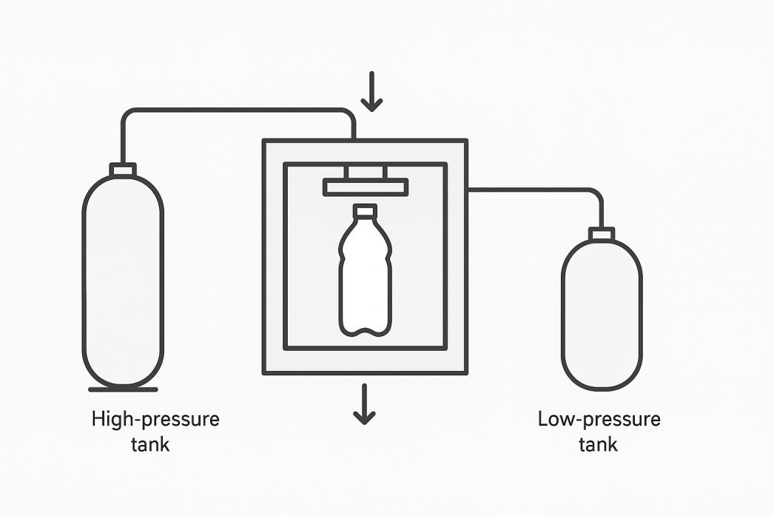
AIR RECOVERY
09
- Energy efficiency meets innovation with our advanced air recovery system. Instead of wasting high-pressure air after blowing, our system intelligently captures and channels it back into the low- pressure circuit.

- This drastically reduces compressor load, cuts energy consumption, and significantly lowers operating costs. With this technology, your machine becomes greener, smarter, and far more economical—saving your business money every single hour of production.


+ 9 1 7 8 2 7 4 3 4 3 9 2 | + 9 1 8 3 6 8 1 2 5 9 7 8
W W W . A L S U N M A C H I N E R Y . C O M




PRECISION DRIVEN
MIG WELDING
- We use professional-grade MIG welding throughout the machine’s framework to deliver maximum structural integrity. Each weld is strong, consistent, and built to handle extreme industrial conditions.

- Unlike ordinary welding, MIG welding ensures perfect penetration with a clean finish, eliminating weak points in the frame. This results in a tougher, more dependable machine that maintains alignment and tolerances even during intense production cycles.

+ 9 1 7 8 2 7 4 3 4 3 9 2 | + 9 1 8 3 6 8 1 2 5 9 7 8

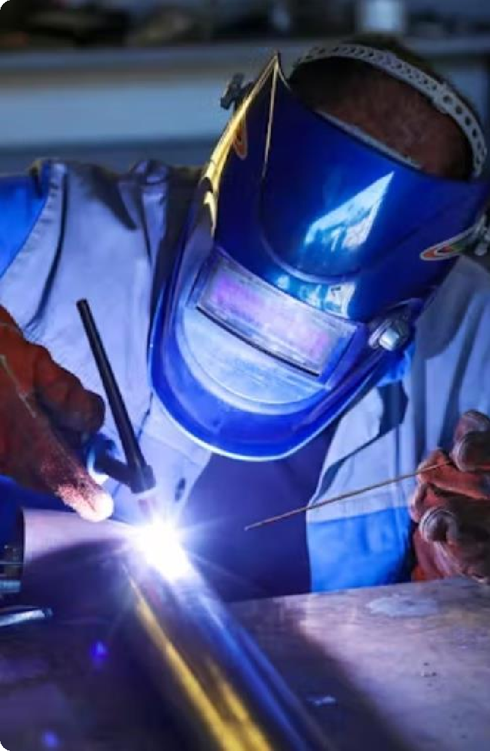
W W W . A L S U N M A C H I N E R Y . C O M
010


AUTO BLACKENING
OF ALL COMPONENTS
011


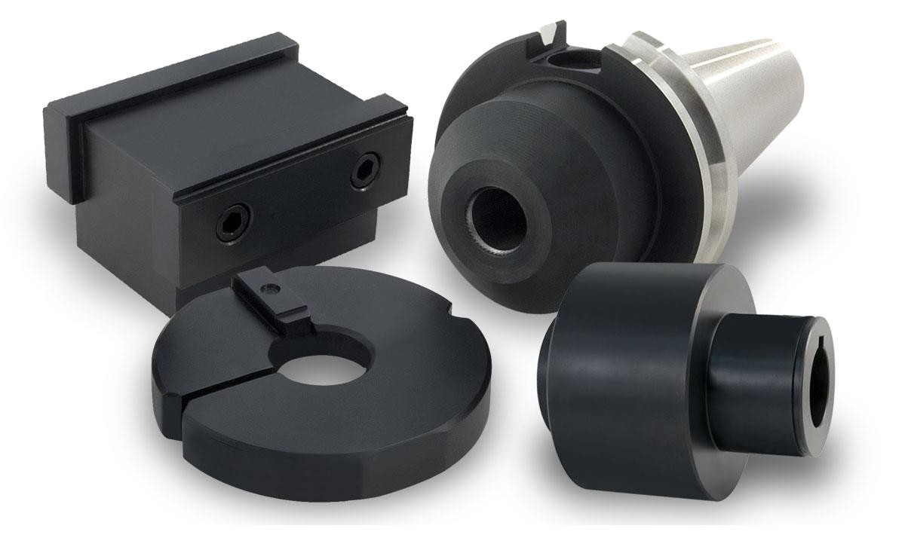

+ 9 1 7 8 2 7 4 3 4 3 9 2 | + 9 1 8 3 6 8 1 2 5 9 7 8
- To guarantee long-lasting performance and protection, every component undergoes a high-quality auto-blacking process. This advanced surface treatment shields the parts from corrosion, moisture, and wear, substantially increasing the overall life of the machine.

- Not only does this ensure durability, but it also gives the machine a premium aesthetic finish that reflects our commitment to craftsmanship and long-term value.

W W W . A L S U N M A C H I N E R Y . C O M



ALL ELECTRICALS & ELECTRONICS FROM

SCHNEIDER ELECTRIC
012
  - To ensure uncompromised reliability and safety, we integrate only Schneider Electric components into our machines. Schneider is a global leader in industrial electrical systems, known for delivering precision, stability, and unmatched durability.

  - By using these premium components, we guarantee consistent control performance, enhanced safety, and long operational life. This is the level of quality that keeps your machine running smoothly and efficiently every single day.


+ 9 1 7 8 2 7 4 3 4 3 9 2 | + 9 1 8 3 6 8 1 2 5 9 7 8
W W W . A L S U N M A C H I N E R Y . C O M




+ 9 1 7 8 2 7 4 3 4 3 9 2 | + 9 1 8 3 6 8 1 2 5 9 7 8
ALL NEW

UPS SYSTEM COMPATIBLE
013

    - To ensure your Automatic and Semi Automatic machines operate without interruption, even in unstable voltage conditions, we offer an integrated UPS system. This setup safeguards the electronics and controls from sudden power fluctuations or failures, allowing the machine to complete ongoing cycles safely.

    - No unexpected shutdowns, no risk of damaged moulds or incomplete bottles—just continuous, protected performance that keeps your production line secure and dependable.

W W W . A L S U N M A C H I N E R Y . C O M


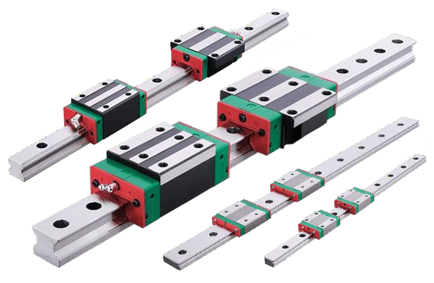
HIWIN
GUIDE RAILS
014

- To achieve perfectly stable and precise plate movement, our machines are equipped with high-accuracy HIWIN guide rails. HIWIN is the industry leading standard for guide rails with their smooth and long lasting properties.

- These rails ensure smooth linear motion, reducing friction, preventing misalignment, and minimizing mechanical wear. The result is consistently accurate performance, reduced maintenance requirements, and long-lasting reliability. This kind of engineering detail directly improves machine life and boosts production quality.


+ 9 1 7 8 2 7 4 3 4 3 9 2 | + 9 1 8 3 6 8 1 2 5 9 7 8
W W W . A L S U N M A C H I N E R Y . C O M




+ 9 1 7 8 2 7 4 3 4 3 9 2 | + 9 1 8 3 6 8 1 2 5 9 7 8

SENSORS

  - Our machines come equipped with intelligent sensors strategically placed across critical points to monitor performance in real time. These sensors ensure safety, detect irregularities instantly, and enable automated adjustments for optimal operation.
015

  - By integrating smart sensing technology, we transform your production line into a more efficient, more reliable, and more controlled environment—reducing human error and maximizing output.

W W W . A L S U N M A C H I N E R Y . C O M




EASY
MOULD MOUNTING
- Time is production, and we’ve engineered our mould mounting
system to make your setup as effortless as possible.

- Designed for quick access and minimal adjustments, operators can mount and change moulds rapidly without special tools or complicated procedures.

- This streamlined process significantly reduces downtime and allows you to switch bottle sizes or shapes with ease—keeping your workflow agile and efficient.

+ 9 1 7 8 2 7 4 3 4 3 9 2 | + 9 1 8 3 6 8 1 2 5 9 7 8

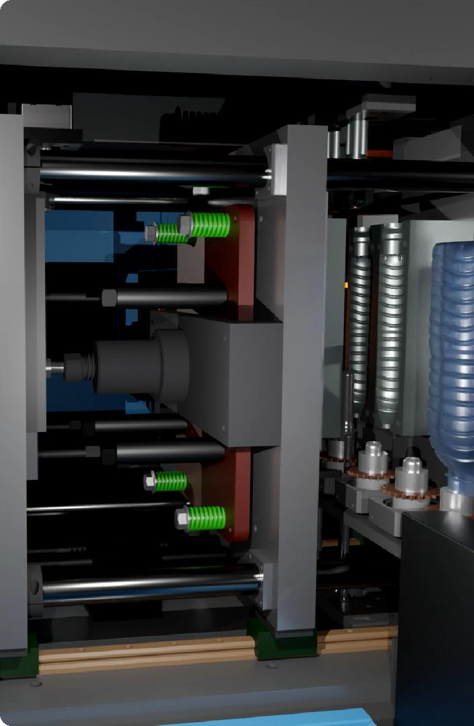
W W W . A L S U N M A C H I N E R Y . C O M
016




+ 9 1 7 8 2 7 4 3 4 3 9 2 | + 9 1 8 3 6 8 1 2 5 9 7 8
SERVICE AVAILABLE


ALL ACROSS COUNTRY
017

  - We believe our relationship with clients extends far beyond the sale. That’s why our service network spans across the entire country, ensuring that expert support is always within your reach.

  - Whether you need on-site assistance, preventive maintenance, or quick troubleshooting, our skilled technicians are ready to respond promptly. With us, you never face downtime alone—your production remains protected by a service team that genuinely cares about your success.

W W W . A L S U N M A C H I N E R Y . C O M




+ 9 1 7 8 2 7 4 3 4 3 9 2 | + 9 1 8 3 6 8 1 2 5 9 7 8
2 YEARS


SERVICE WARRANTY
018
- We stand boldly and confidently behind the quality of our engineering. That’s why every machine comes with a full 2-year warranty that covers major components and manufacturing defects.

- This isn’t just a guarantee—it’s our promise that you’re investing in
something built with honesty, durability, and pride.

- When you choose us, you choose a partner committed to long- term performance and reliability.

W W W . A L S U N M A C H I N E R Y . C O M



CONTACT US

www.alsunmachinery.com
019


B-53B, B Block, Kalkaji, New Delhi, 110019

K-25, Kasna, Surajpur, Site V, UPSIDC, Greater Noida, Uttar Pradesh, 201310


+91 78274 34392

+91 83681 25978

A L S U N M A C H I N E R Y

